Part A — Practice Programs (Hour 1)
Work these in your lab-NN/ folder before the project: do the first one or two in the lab; the last (For Advanced Learners) is for home.
1. Smart thermostat (Thermostat.java, main in this file)
(a) Create class Thermostat with private String location, private int temperature, private static final int MIN=16 and MAX=30, and private static int activeCount=0.
(b) Constructor(location, startTemp): store location; set temperature to startTemp if it is within MIN..MAX else 22; increment activeCount.
(c) Constructor(location): chain with this(location, 22).
(d) raise(): if temperature < MAX add 1, else print “Already at maximum (30)”.
(e) lower(): if temperature > MIN subtract 1, else print “Already at minimum (16)”.
(f) Add getTemperature() (no setter) and static getActiveCount().
(g) In main: create two thermostats, call raise() 10 times then lower() 20 times in loops (printing the temperature each time), then print getActiveCount().
Code | public class Thermostat {  private int temperature;  private static int activeCount = 0;  public Thermostat(String var1, int var2) {  if (var2 >= 16 && var2 <= 30) {  this.temperature = var2;  } else {  this.temperature = 22;  }  ++activeCount;  }  public Thermostat(String var1) {  this(var1, 22);  }  public void raise() {  if (this.temperature < 30) {  ++this.temperature;  } else {  System.out.println("Already at maximum (30)");  }  }  public void lower() {  if (this.temperature > 16) {  --this.temperature;  } else {  System.out.println("Already at minimum (16)");  }  }  public int getTemperature() {  return this.temperature;  }  public static int getActiveCount() {  return activeCount;  }  public static void main(String[] args) {  Thermostat var1 = new Thermostat("Living Room");  new Thermostat("Bedroom", 25);  for(int var3 = 0; var3 < 10; ++var3) {  var1.raise();  System.out.println(var1.getTemperature());  }  for(int var4 = 0; var4 < 20; ++var4) {  var1.lower();  System.out.println(var1.getTemperature());  }  System.out.println(getActiveCount());  }  }
Output | 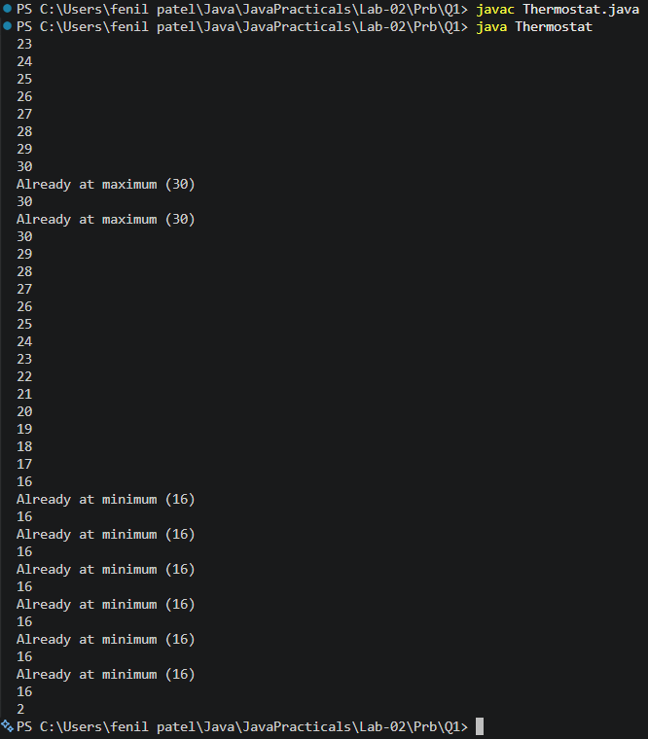

2. Cinema show (CinemaShow.java, main in this file)
(a) Create class CinemaShow with private String title, private int seatsAvailable, private final int capacity, and private static int totalBooked=0.
(b) Constructor(title, capacity): set both and seatsAvailable = capacity. Constructor(title): chain with this(title, 100).
(c) book(int n): if n ≤ seatsAvailable, reduce seatsAvailable by n, add n to totalBooked, return true; else return false unchanged.
(d) cancel(int n): increase seatsAvailable by n but never above capacity.
(e) Add getSeatsAvailable() and static getTotalBooked().
(f) In main: run a sequence of book and cancel calls, printing the result and seats after each, then print getTotalBooked().

Code | import java.util.*;  public class CinemaShow {  private int seatsAvailable;  private final int capacity;  private static int totalBooked=0;  public CinemaShow(String t,int c){  capacity=c;  seatsAvailable=capacity;  }  public CinemaShow(String t){  this(t,100);  }  public boolean book (int n){  if(n<=seatsAvailable){  seatsAvailable-=n;  totalBooked+=n;  return true;  }  else{  return false;  }  }  public void cancel(int n){  seatsAvailable+=n;  if(seatsAvailable>capacity){  seatsAvailable=capacity;  }  }  public int getSeatsAvailable(){  return seatsAvailable;  }  public static int getTotalBooked(){  return totalBooked;  }  public static void main(String[] args){  Scanner s= new Scanner(System.in);  int cap;  System.out.print("Enter capcaity of cinema:");  cap=s.nextInt();  s.nextLine();  String t;  System.out.print("Enter movie:");  t=s.nextLine();  CinemaShow c= new CinemaShow(t,cap);  while (true){  System.out.println("1. Book ticket");  System.out.println("2. Cancel ticket");  System.out.println("3. Show Available Seats");  System.out.println("4. Exit");  System.out.print("Enter your choice:");  int choice=s.nextInt();  switch ((choice)) {  case 1:  System.out.print("Enter number of tickets:");  int ti=s.nextInt();  boolean result = c.book(ti);  System.out.println("Booking Successful:" + result);  System.out.println("Seats Available:" + c.getSeatsAvailable());  break;  case 2:  System.out.print("Enter number of tickets to cancel:");  int cancel = s.nextInt();  c.cancel(cancel);  System.out.println("Seats Available:" + c.getSeatsAvailable());  break;  case 3:  System.out.println("Seats Available:" + c.getSeatsAvailable());  break;  case 4:  System.out.println("Total Successful Bookings: " + CinemaShow.getTotalBooked());  s.close();  return;  default:  System.out.println("Invalid Choice!");  }  }  }  }
Output | 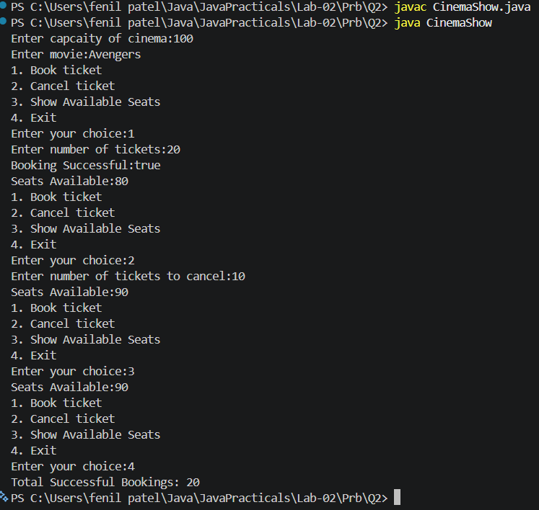

3. (For Advanced Learners – home) Parking lot (ParkingLot.java)
(a) Create class ParkingLot with private int twoWheelers and fourWheelers, private final int twoCap and fourCap, and private static long revenue=0.
(b) park(String type): for “two”, if twoWheelers < twoCap increment and add 20 to revenue; for “four”, if fourWheelers < fourCap increment and add 40; otherwise print “Full” and reject.
(c) leave(String type): decrement the matching count but never below 0.
(d) In main: simulate a sequence of park/leave events, printing each outcome, then print final occupancy and revenue.
Code | import java.util.*;  public class ParkingLot {  private int twoWheelers;  private int fourWheelers;  private final int twoCap;  private final int fourCap;  private static long revenue=0;  public ParkingLot(int twoCap, int fourCap) {  this.twoCap = twoCap;  this.fourCap = fourCap;  twoWheelers = 0;  fourWheelers = 0;  }  public void park(String type){  switch (type.toUpperCase()) {  case "TWO":  if(twoWheelers<twoCap){  twoWheelers++;  revenue+=20;  }  else{  System.out.println("FULL");  }  break;  case "FOUR":  if(fourWheelers<fourCap){  fourWheelers++;  revenue+=40;  }  else{  System.out.println("FULL");  }  break;  default:  System.out.println("Invalid type");  }  }  public void leave(String t){  switch (t.toUpperCase()) {  case "TWO":  if(twoWheelers>0){  twoWheelers--;  }  else{  System.out.println("Empty");  }  break;  case "FOUR":  if(fourWheelers>0){  fourWheelers--;  }  else{  System.out.println("Empty");  }  break;  default:  System.out.println("Invalid type");  }  }  public int getTwoWheelers() {  return twoWheelers;  }  public int getFourWheelers() {  return fourWheelers;  }  public static long getRevenue() {  return revenue;  }  public static void main(String[] args){  Scanner s=new Scanner(System.in);  System.out.print("Enter two-wheeler capacity:");  int two = s.nextInt();  System.out.print("Enter four-wheeler capacity:");  int four = s.nextInt();  ParkingLot p= new ParkingLot(two, four);  while(true){  System.out.println("1. Park Vehicle");  System.out.println("2. Leave Vehicle");  System.out.println("3. Show Status");  System.out.println("4. Exit");  System.out.print("Enter choice: ");  int choice = s.nextInt();  switch (choice) {  case 1:  System.out.print("Enter vehicle type: ");  String type = s.next();  p.park(type);  System.out.println("Two-Wheelers:" + p.getTwoWheelers());  System.out.println("Four-Wheelers:" + p.getFourWheelers());  break;  case 2:  System.out.print("Enter vehicle type: ");  String ty = s.next();  p.leave(ty);  System.out.println("Two-Wheelers:" + p.getTwoWheelers());  System.out.println("Four-Wheelers:" + p.getFourWheelers());  break;  case 3:  System.out.println("Two-Wheelers:" + p.getTwoWheelers());  System.out.println("Four-Wheelers:" + p.getFourWheelers());  System.out.println("Revenue: Rs. " + ParkingLot.getRevenue());  break;  case 4:  System.out.println("Final Occupancy");  System.out.println("Two-Wheelers :" + p.getTwoWheelers());  System.out.println("Four-Wheelers:" + p.getFourWheelers());  System.out.println("Total Revenue:Rs. " + ParkingLot.getRevenue());  s.close();  default:  System.out.println("Invalid Choice");  }  }  }  }
Output | 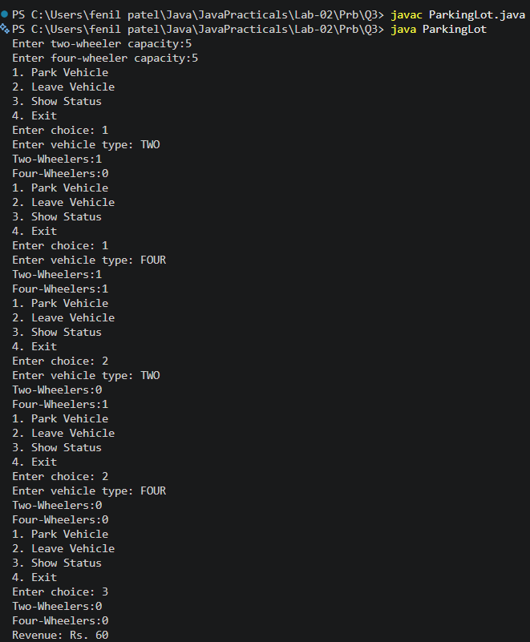

Part B — Project Work (Hour 2): MiniBank
In Practical 1 you built the empty menu shell. Now you create the data the bank works on — the Customer and Account classes. Using encapsulation, an account’s balance can change only through deposit() and withdraw(), never directly. These two classes are the foundation every later lab extends.
1. Create a class named Customer with private fields name, email and mobile (all String) and a private final field customerId (String). Use a private static long field customerCounter and a private static method generateCustomerId() to create ids such as “CUST101”. Add a constructor and public getter methods.
2. Create a class named Account with private fields: a final String accountNumber, a String ownerName, a long balance (whole rupees) and a boolean active. Generate accountNumber with a private static counter (for example “AC0001”).
3. Add two constructors to Account: one taking ownerName and an opening balance; one taking only ownerName that calls the first using this(ownerName, 0).
4. Add a public method deposit(long amount) that adds amount to balance. Add a public method withdraw(long amount) that subtracts amount and returns true when the balance is sufficient, otherwise returns false without changing the balance. Add getter methods. Do NOT add a public setter for balance.
5. In main, create three Account objects inside an Account[] array, perform a few deposits and withdrawals, and print each balance.

Code | import java.util.*;  public class MiniBank {  enum MenuOption {  OPEN_ACCOUNT,  DEPOSIT,  WITHDRAW,  TRANSFER,  EXIT  }  record BankInfo(String name, String branch) {  }  public static void main(String[] args) {  BankInfo bank = new BankInfo("MiniBank", "Ahmedabad Branch");  Scanner s = new Scanner(System.in);  boolean run = true;  Account[] accounts = new Account[3];  accounts[0] = new Account("Fenil", 5000);  accounts[1] = new Account("Heer", 10000);  accounts[2] = new Account("Amit");  while (run) {  System.out.println("\n--------------------");  System.out.println(bank.name() + " - " + bank.branch());  System.out.println("1) Open Account");  System.out.println("2) Deposit");  System.out.println("3) Withdraw");  System.out.println("4) Transfer");  System.out.println("5) Exit");  System.out.print("Enter your choice:");  int choice = s.nextInt();  MenuOption option;  switch (choice) {  case 1:  option = MenuOption.OPEN_ACCOUNT;  break;  case 2:  option = MenuOption.DEPOSIT;  break;  case 3:  option = MenuOption.WITHDRAW;  break;  case 4:  option = MenuOption.TRANSFER;  break;  case 5:  option = MenuOption.EXIT;  break;  default:  option = null;  }  if (option == null) {  System.out.println("Invalid Choice");  continue;  }  switch (option) {  case OPEN_ACCOUNT -> {  System.out.println("\nAccounts Created Successfully");  System.out.println(accounts[0].getAccountNumber() + " | "+ accounts[0].getOwnerName() + " | Balance = " + accounts[0].getBalance());  System.out.println(accounts[1].getAccountNumber() + " | "+ accounts[1].getOwnerName() + " | Balance = " + accounts[1].getBalance());  System.out.println(accounts[2].getAccountNumber() + " | "+ accounts[2].getOwnerName() + " | Balance = " + accounts[2].getBalance());  }  case DEPOSIT -> {  System.out.println("Select Account");  System.out.println("1." + accounts[0].getOwnerName());  System.out.println("2." + accounts[1].getOwnerName());  System.out.println("3." + accounts[2].getOwnerName());  int acc = s.nextInt();  System.out.print("Enter Amount:");  long amount = s.nextLong();  switch (acc) {  case 1:  accounts[0].deposit(amount);  System.out.println("Balance =" + accounts[0].getBalance());  break;  case 2:  accounts[1].deposit(amount);  System.out.println("Balance =" + accounts[1].getBalance());  break;  case 3:  accounts[2].deposit(amount);  System.out.println("Balance =" + accounts[2].getBalance());  break;  default:  System.out.println("Invalid Account");  }  }  case WITHDRAW -> {  System.out.println("Select Account");  System.out.println("1. " + accounts[0].getOwnerName());  System.out.println("2. " + accounts[1].getOwnerName());  System.out.println("3. " + accounts[2].getOwnerName());  int acc = s.nextInt();  System.out.print("Enter Amount:");  long amount = s.nextLong();  switch (acc) {  case 1:  if (accounts[0].withdraw(amount))  System.out.println("Withdrawal Successful");  else  System.out.println("Insufficient Balance");  System.out.println("Balance =" + accounts[0].getBalance());  break;  case 2:  if (accounts[1].withdraw(amount))  System.out.println("Withdrawal Successful");  else  System.out.println("Insufficient Balance");  System.out.println("Balance =" + accounts[1].getBalance());  break;  case 3:  if (accounts[2].withdraw(amount))  System.out.println("Withdrawal Successful");  else  System.out.println("Insufficient Balance");  System.out.println("Balance =" + accounts[2].getBalance());  break;  default:  System.out.println("Invalid Account");  }  }  case TRANSFER -> {  System.out.println("Transfer feature will be implemented later");  }  case EXIT -> {  System.out.println("Thank you for using MiniBank.");  run = false;  }  }  }  s.close();  }  }  class Customer {  private String name;  private String email;  private String mobile;  private final String customerId;  private static long customerCounter = 100;  private static String generateCustomerId() {  customerCounter++;  return "CUST" + customerCounter;  }  public Customer(String name, String email, String mobile) {  this.name = name;  this.email = email;  this.mobile = mobile;  this.customerId = generateCustomerId();  }  public String getName() {  return name;  }  public String getEmail() {  return email;  }  public String getMobile() {  return mobile;  }  public String getCustomerId() {  return customerId;  }  }  class Account {  private final String accountNumber;  private String ownerName;  private long balance;  private boolean active;  private static int accountCounter = 0;  private static String generateAccountNumber() {  accountCounter++;  return String.format("AC%04d", accountCounter);  }  public Account(String ownerName, long openingBalance) {  this.ownerName = ownerName;  this.balance = openingBalance;  this.active = true;  this.accountNumber = generateAccountNumber();  }  public Account(String ownerName) {  this(ownerName, 0);  }  public void deposit(long amount) {  if (amount > 0) {  balance += amount;  }  }  public boolean withdraw(long amount) {  if (amount <= balance) {  balance -= amount;  return true;  }  return false;  }  public String getAccountNumber() {  return accountNumber;  }  public String getOwnerName() {  return ownerName;  }  public long getBalance() {  return balance;  }  public boolean isActive() {  return active;  }  }
Output | 